(Approx. 935 words)

Back to Basics
Internet Browser Tools
By Jim Cerny, Columnist, Sarasota TUG, FL
August 2015 issue, Sarasota Technology Monitor
www.thestug.org / jimcerny123 (at) gmail.com

The Internet is a tremendous resource for everything. It is probably the number one reason for having a computer – to get to the internet. In addition for paying for access to the internet, you need a free program called an internet “browser” that allows you to view the internet web pages. One of the more popular browser programs is Internet Explorer (by Microsoft) which comes free on all Windows computers. Other free browser programs are Safari, Google Chrome, and Firefox which can be downloaded from the Internet for free. Using any of these browser programs is easy but, as usual, there are many options and tools available to you. This article will introduce you to the purpose and use of “tabs” (on Internet Explorer).

Along the top of your internet browser program window will be a row that will contain one or more “tabs” (please see the illustration).

Just to the right of the web page address box you can see that I have three tabs, “Golf
drivi…”, “Gmail”, and “HERSH..”. If I move my mouse over any of these tabs (hover your mouse, do not click it) I will see the full title of that web page and its address. If I click on any of these tabs, I will see that web page right away. So, you could say that tabs are an easy and quick way to go to a specific web page without having to open a new browser window or using “favorites”.
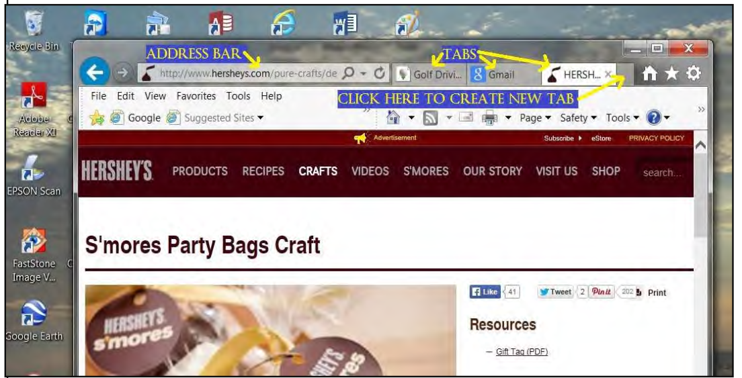
Perhaps you have never created a tab (that you know of, anyway) and you are wondering how you get them. Web pages are designed to have the ability to send you to another web page with the click of your mouse. Certain items you see on a web page, such as colored text, underlined text, photos, or headlines, etc. are called “hot links”. Clicking on any such link will display a new web page – the web page to which that link directs you. The new web page address will appear in the “address bar” at the top of the window. In the old days, clicking on a hotlink would always open that new web page in a new window OR display that web page in your existing window. Today many hotlinks will add a new “tab” while taking you to that page. This way, if you visit other web pages, you can go back to a web page by clicking on its tab -- you do not have to “hunt” for it by clicking on the “previous web page” arrow multiple times or open your history list. Basically, it is a shortcut to a web page. You do not have to use “tabs” if you do not want to, using them is optional. When you click on a hot link, you do not know in advance how that new web page will appear – it may be in a new window, a new tab, or in your existing window. It is not unusual to use the internet, exploring and clicking away, and ending up with several or many new tabs.

You can create a new tab yourself if you wish just by clicking on the “New tab” (a blank tab) as shown in the illustration. After you click to create the new tab you will have to go to the web page you want for that tab, such as by entering the address in the address bar. To remove or “close” any tab, move your mouse to that tab and click on the small “X” that appears on the right side of that tab. You should not have more than a few tabs at any one time. As new tabs are created (either by you or by clicking on links) they become more squeezed together and are harder to read. Of course you can hover your mouse on any tab to see what it is if you wish. When you exit your web browser, most likely the tabs that have been created during your previous session will be gone. If you want to make some tabs permanent, so they appear every time you open Internet Explorer, you can do that by going to Tools – Internet Options – General – then add the web pages you want as tabs in the “Home page” box. I don’t use tabs that much, I still like and use “favorites” to go to my favorite web pages. But I did create a permanent tab for my Gmail web page which I use every time I do email.

I do recommend that you close all program windows when you are through using that program (such as your internet browser program) and shutting down your computer at the end of the day. This prevents programs staying open over long periods of time and building up multiple things like tabs, links, history, etc., until there are just too many clogging up your screen. If you do leave your computer on for long periods of time, you may want to check to see how many tabs are in your window and delete the ones you do not want.

If you are interested in using tabs in your browser program and want to learn more about them, please use Google and ask specifically “How do I use tabs in Internet Explorer on Windows X”, or for whatever browser you are using. Tabs can be helpful but at least they are optional (so far, anyway).

